**Proposal For An Autonomous Map Making Robot**

January 29th 2018

**Group 2F:**

Sashank Bandemegala

Nicholas DiPaolo

Adam O’Reilly

Chantel Lepage

Luwan Wang

Aaron Chiu

Submitted to—

Dr. Alan Steele, Dr. Hicham Chaoui

Department of Electronics, Carleton University

**Contents**

Project Overview 3

Introduction X

Background Information on Autonomous Robots X

Project Description X

Parts X

Project Schematic X

Approach to the Design X

Potential Risk and Safety Assessment X

Project Management X

Budget X

Deliverables X

Roles and Responsibilities X

X

Conclusion X

References X

**Proposal for an Autonomous Map Making Robot**

**1.0 Introduction**

This proposal document is a requirement of the course ELEC 3907. The purpose of this group produced document is to obtain the approval of the projects area of interest, team membership, parts procurement, and the construction of the project. This proposal will include a list of design goals, a chart of the project elements and specifications, a chart of the timeline of the project and a breakdown of the roles and responsibilities amongst the group. A project schedule will be included to show how the project deliverables will be planned out and the time being spent on each deliverable.

**2.0 Background Information on Autonomous Robots**

This project will be based on an autonomous robot and implementing various sensors and modules. A microcontroller is the main component that controls the various parts individually. The microcontroller follows commands that have been inputted through coding software on a computer. Since the robot has multiple goals, they must have different components to complete each of its goals. Various sensors could be used to achieve autonomous movement of robots such as ultrasonic sensors, Radar sensors or camera sensors. They all have a similar process in which the module sends out a pulse of waves and measures the reflection off an object. The information received from the sensors could be analyzed by software to provide the robot with its next move. The movement of the robot involves 3 main components, an h-bridge to allow for forward and backward movement, motors to convert electrical current into mechanical torque, and wheels to use the torque and move the robot. Together, the components work together with the software for an autonomous robot.

The project that the team has come up, with was an autonomous robot that uses the method above but also include the ability to create a 2-dimensional map of the surroundings and include a live feed of what the robot sees. This would all be done autonomously without the need for a human to control where the robot goes. The map making process would be done through software implementation reading the information provided by the ultrasonic sensor through the Arduino microcontroller.

**3.0 Project Description**

This project will rely on the fact that a microcontroller controls all the processes of the robot. Using various sensors and modules coinciding with software programming, the autonomous robot will be able to carry out its various duties. The robot will need to detect and avoid obstacles with the use of ultrasonic sensors. These sensors will be connected to an arduino which will control DC motors that are directly connected to wheels.

**3.1 Parts**

The project requires various parts and each of them have a very specific role. In order to build a robot that is able to move, motor drivers and wheels are required. Ultrasonic sensors are being used for the purpose of moving autonomously as well as creating a 2D map. To achieve a live feed of what the robot sees, a camera module is being used to broadcast the video feed on to an external device through RF capabilities. A power supply is required in order to power the main components as well as the motor drivers. All together, an Arduino microcontroller is being used to control all the individual parts and the amount of each parts being used are shown in Table #below.

|  |  |
| --- | --- |
| **Required Parts** | **Amount** |
| Wheels | 2 |
| Ultrasonic Sensors | 4 |
| Motors | 2 |
| Prototype Board | 2 |
| Arduino Nano | 1 |
| DC Motor Plug | 1 |
| Power supply | 1 |

**3.1.1 Ultrasonic Sensor**

An ultrasonic sensor is a tool used to measure the distance from its current location to an object that is in front of it, using an ultrasonic wave. An ultrasonic wave is a sound wave that is undetectable to the human ear but could be processed with a specific receiver. Since the sensor is using a sound wave as opposed to a light wave, the senor would still be able to work as normal regardless of the lighting conditions.

The sensor is able to do this by transmitting and receiving an ultrasonic wave, it transmits a wave and waits for its response in the reciever. By tracking the time between the wave leaving the sensor and gets back to the sensor, it is able to determine the distance of the object from its current position.

These sensors will be a big part of the project as they will be used to make the robot autonomous as well as to generate a 2D map. For the movement, information can be taken from the sensor and then using the microcontroller, when the sensor detects a distance that is too close to an object the robot will turn a different direction. The map can be generated by using the information from the sensors, every point that is reflected back into the sensor would be stored and then simulated on an external device to create a map.

**3.1.2 Camera Module** - chantel lepage

**3.1.3 Power Supply** - Aaron Chiu

The power supply will be based around an LM317 voltage regulator. It will be connected to a 6v battery. The battery will be connected to the h-bridge and the voltage regulator in parallel. The voltage regulator will supply the Arduino with 5v with an input of 6v from the battery. The h-bridges will use the entire 6v range since the motors need 6v to run.

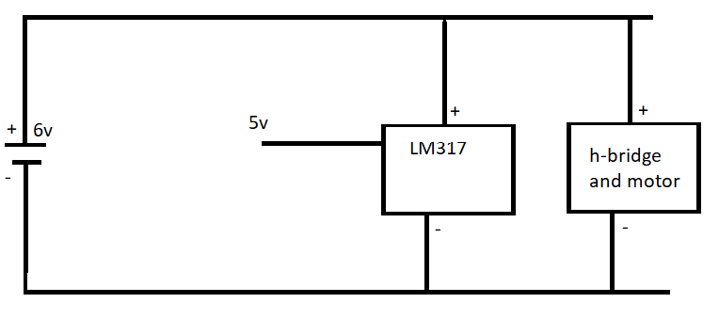

**3.1.4 Motor Driver**

A DC motor plug is used to control the movement of the robot. A DC motor plug is a very simple way to control a DC motor, it consists of 2 h-bridges allowing us to control 2 small DC motors at the same time[1].

The DC motor plug is intended to drive a single stepper motor, but also works for driving 2 small DC motors, going forward and backwards. The plug includes 12 male pin to be able to connect to the Arduino, and 12 female pins to connect to the motors. The female pins are split into 2 with 6 pins being for one DC motor and the other 6 being for the other motor [1].

The DC motor plug is being used instead of building an h-bridge from scratch, mainly because of power consumption and size. The DC motor plug is very small and lightweight, allowing for more room on the car and due to its light weight, the car will require less force to move. Having the ability to control each motor will allow for the car to turn on a dime, making it easier to control and maneuver obstetrics.

**3.1.5 Body**

The body will be measured, drawn and printed using a 3D printer. The chassis will be built into the body. The body will be made out of plastic which has been created through Autocad after precise measurements of the wheels, motors and sensors. The motors will be placed in the front of the body and an ultrasonic sensor will be placed on each side of the body. The center of the chassis will hold the electronics. Figure ## below shows the underbody of the robots body. The electronic components will be underneath and hidden from the eye.

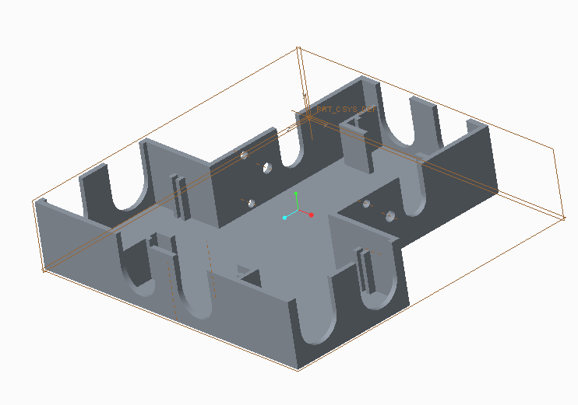

**3.1.6 Arduino Microcontroller chantel**

**3.2 Project Schematic**

The robot will have three wheels, two rubber wheels and one small support wheel. In order to turn the vehicle, one motor controls the car to roll forward and the other to roll backwards. It is easier for the car to turn with three wheels than four wheels, therefore three wheels are chosen for the design. There will be four ultrasonic sensors in each side of the car. Those sensors will measure the distance from the car to its surrounding obstacles and send the data to the microcontroller on the middle. Camera will be added to the car to send a real time video to another device for a user friendly purpose. When put together, it will look like Figure # below.

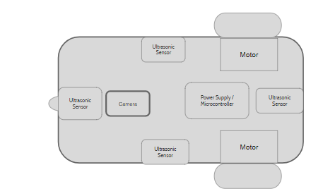

Figure 1: Top view of Autonomous map making robot design

**3.3 Possible approaches to design solution**

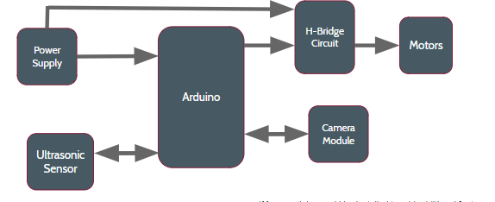

Figure 2: High level design of map making robot

As shown in Figure 2, the power supply supports the Arduino and the motors. The ultrasonic sensors measures the distance from the sensor to the surrounding obstacles and communicates with Arduino to make a 2-D map. H bridge is used to enable the motor to rotate clockwise and anti clockwise. Each motor controls one rubber wheel of the car. Camera module will be connected with Arduino and Arduino will send a real-time video to another device.

4.0 Project Management

The 6 member group was created randomly by the professor counting numbers from 1 through 8. Although the groups were created randomly, they team that was created work nice together. The budget for the project, timeline of the project deliverables, as well as the roles and responsibilities of each individual are shown below.

4.1 Budget

The budget for this project has been set to $100 including tax and shipping costs. This budget has been established by the professors of the course. The parts are being ordered from various websites that were suggested by the parts procurement teaching assistant. Although the budget is $100, some parts were found within the lab which were available for the group to use. The parts that were found in the lab are not being included in the budget but they are included within the costs shown in Table ## below.

|  |  |
| --- | --- |
| **Required Parts** | **Cost** |
| Rubber Wheels | 2 @ $2.20 each = $5.20 |
| Small Wheel | $0 3D printed |
| Ultrasonic Sensors | 4 @ $4.39 = $17.96 |
| Motors | 2 @ $3.50 = $7.00 |
| Prototype Board | 2 @ $1.92 each = $3.84 |
| Arduino Nano | $9.99 |
| Dual H bridge | $5.00 |
| Power supply | $34.42 |
| **Total** | **$83.4** |

4.2 Deliverables

As shown in Table X, each small feature will be added each week. Except for making a 2-d map. The software group will start to program the relative code when the ultrasonic sensors and assembled as it is the most important feature of this robot. There will be 16 days left for final adjustment and testing in case some tasks run over the expected time.

|  |  |  |  |
| --- | --- | --- | --- |
| Task Name | Start | End | Duration/days |
| Ordering of main parts | 2018-01-22 | 2018-01-29 | 7 |
| Overall high-level design | 2018-01-29 | 2018-02-05 | 7 |
| Assembling main robot parts | 2018-02-05 | 2018-02-12 | 7 |
| Testing for basic movement | 2018-02-12 | 2018-02-19 | 7 |
| Assembling ultrasonic sensors | 2018-02-19 | 2018-02-26 | 7 |
| Programing and testing for autonomous movement | 2018-02-26 | 2018-03-05 | 7 |
| Software implementation of making a 2D map | 2018-02-26 | 2018-03-12 | 14 |
| Test of mapping and adding camera module | 2018-03-12 | 2018-03-19 | 7 |
| Programing and testing of sending real time video | 2018-03-19 | 2018-03-26 | 7 |
| Final test and adjustment | 2018-03-26 | 2018-04-11 | 16 |

Tablex: Expected timeline for autonomous map making project

The Gantt chart below demonstrates the timeline in a better way.

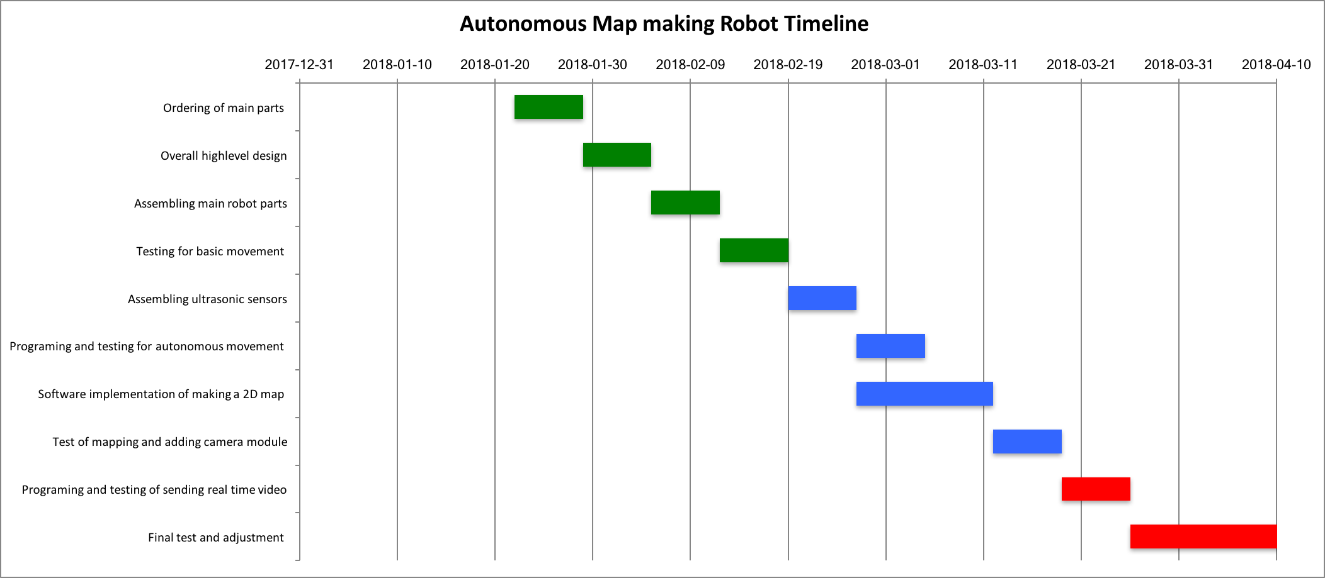

Figure : Gantt chart of autonomous map making robot timeline

4.3 Roles and Responsibilities

With the group having 6 team members and a lot of work needed that is to be done, the group has been split up evenly with everyone having primary and secondary roles. The primary role is the main interest of the individual and what the team member feels most comfortable with. The secondary role was introduced to bring new ideas in and help another team member brainstorm or build the components.

|  |  |  |  |
| --- | --- | --- | --- |
| Name | Primary | Secondary | Specific Topic |
| Sashank Bandemegala | Hardware | N/A | Camera Module |
| Nicholas DiPaolo | Hardware | Software | Motor Drivers |
| Adam O’Reilly | Software | Hardware | Motor Drivers |
| Chantel Lepage | Software | Hardware | Autonomous driving |
| Luwan Wang | Software | N/A | 2D Map Making |
| Aaron Chiu | Hardware | Software | Autonomous driving |

The project deliverables and the schedule is shown below.

5.0 Conclusion

The purpose of this group proposal is to obtain the approval of the projects area of interest, parts procurement, design and the construction of the project. The proposal outlines how all the project deliverables will be organized with all the team members as well as everyone's roles and responsibilities. This project has many uses other than the one it was built for. Apart from creating a map and having a live camera feed of what the robot sees, it will have the ability to add additional modules on it for further features on the same robot.

[1] <https://www.digitalsmarties.net/products/dc-motor-plug>